

**Placement Empowerment Program**

***Cloud Computing and DevOps Centre***

**Use Cloud Storage in Azure Portal**

Name: Aksha S Department: CSE

**Step 1: Create a Storage Account**

1. Go to the [**Azure Portal**](https://portal.azure.com/) and sign in.
2. Search for **"Storage accounts"** in the top search bar and click on it.
3. Click **"Create"** to create a new storage account.
4. Fill in the required details:
   * **Subscription**: Select your subscription.
   * **Resource Group**: Create a new one or select an existing one.
   * **Storage account name**: Choose a unique name (e.g., mycloudstorage).
   * **Region**: Select the region closest to you.

Click **"Review + Create"**, then **"Create"**

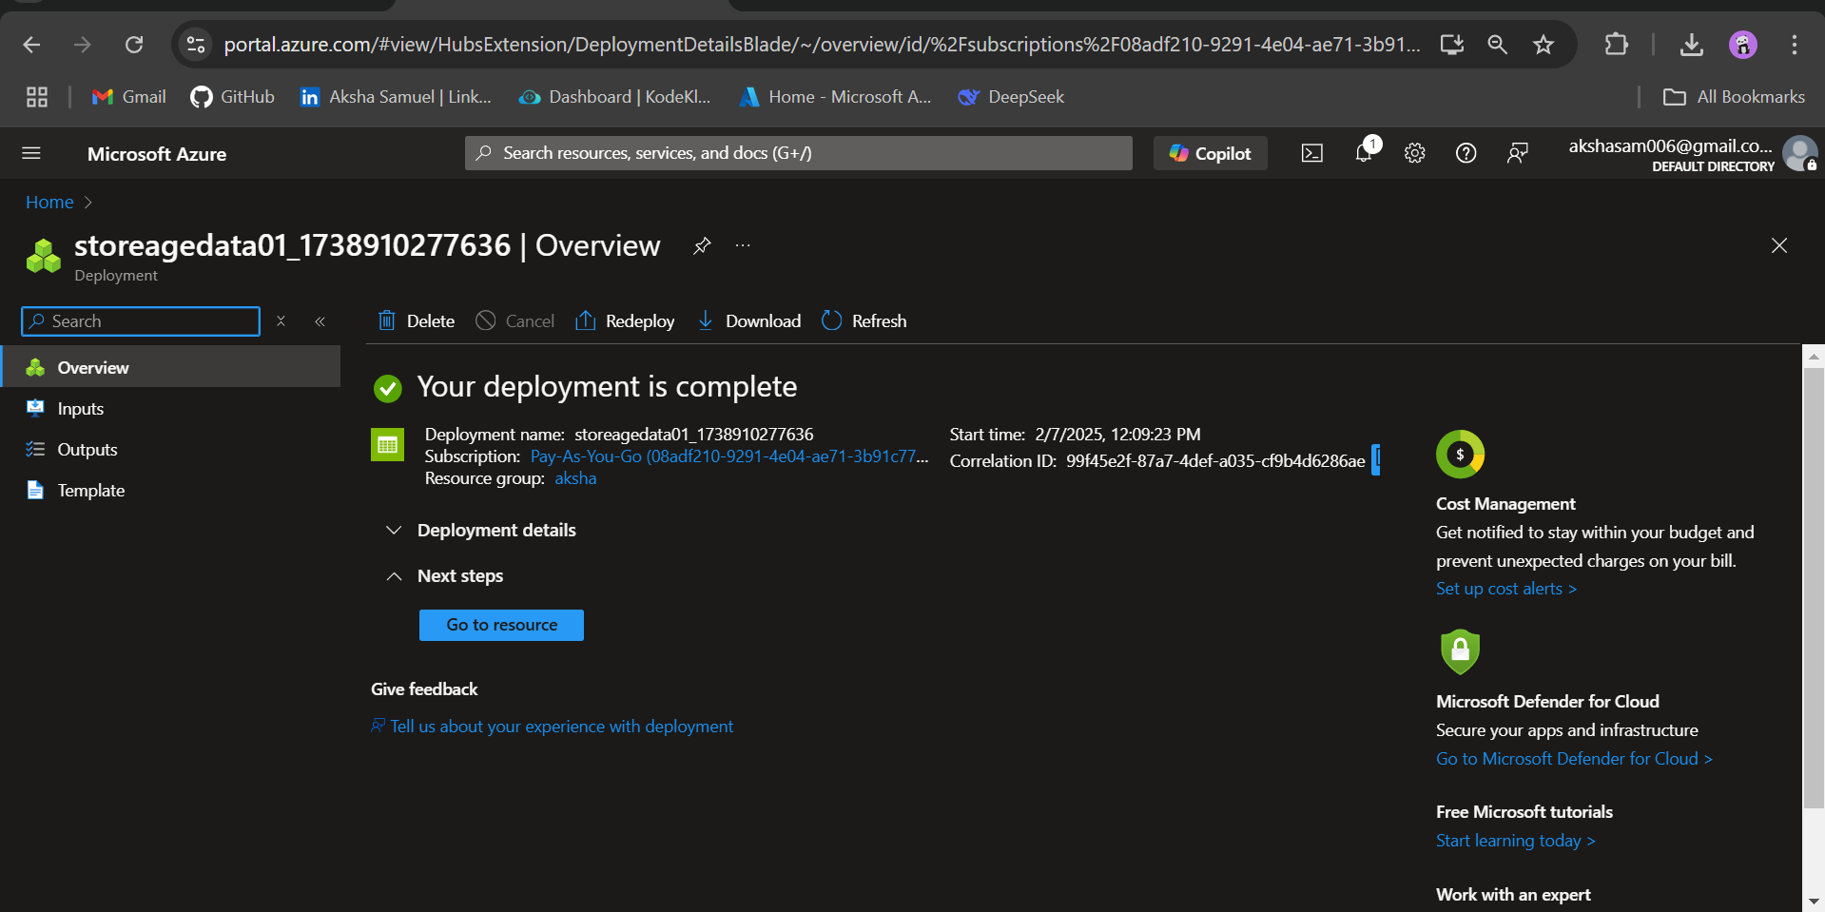

**Step 2:**

**Create a Blob Container**

1. After deployment, go to your **Storage Account**.
2. In the left menu, click **"Containers"** under the **Data storage** section.
3. Click **"+ Container"**, enter a name (e.g., my-container), and set the **Public access level**:
   * **Private (default)**: Only users with authentication can access it.
   * **Blob**: Allows anonymous read access for blobs.
   * **Container**: Allows anonymous read access for the entire container.
4. Click **"Create"**.

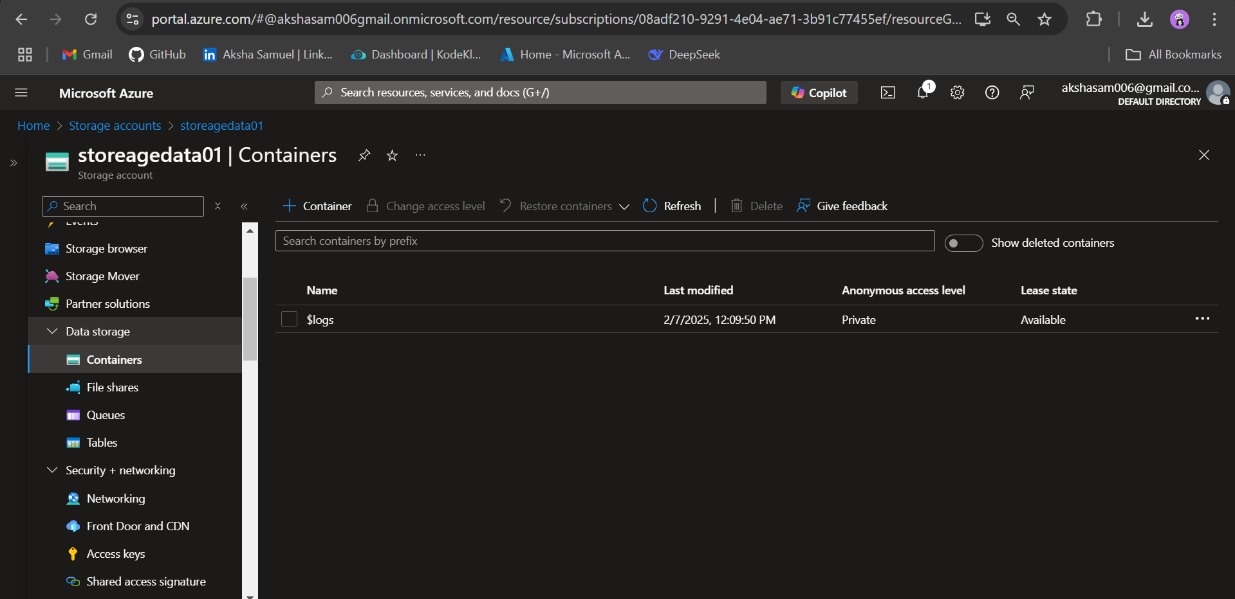

**Step 3: Upload Files to the Blob Container**

1. Open the **Blob Container** you created.
2. Click **"Upload"**.
3. Click **"Browse for files"** and select the files to upload.
4. Click **"Upload"** to store files in Azure.

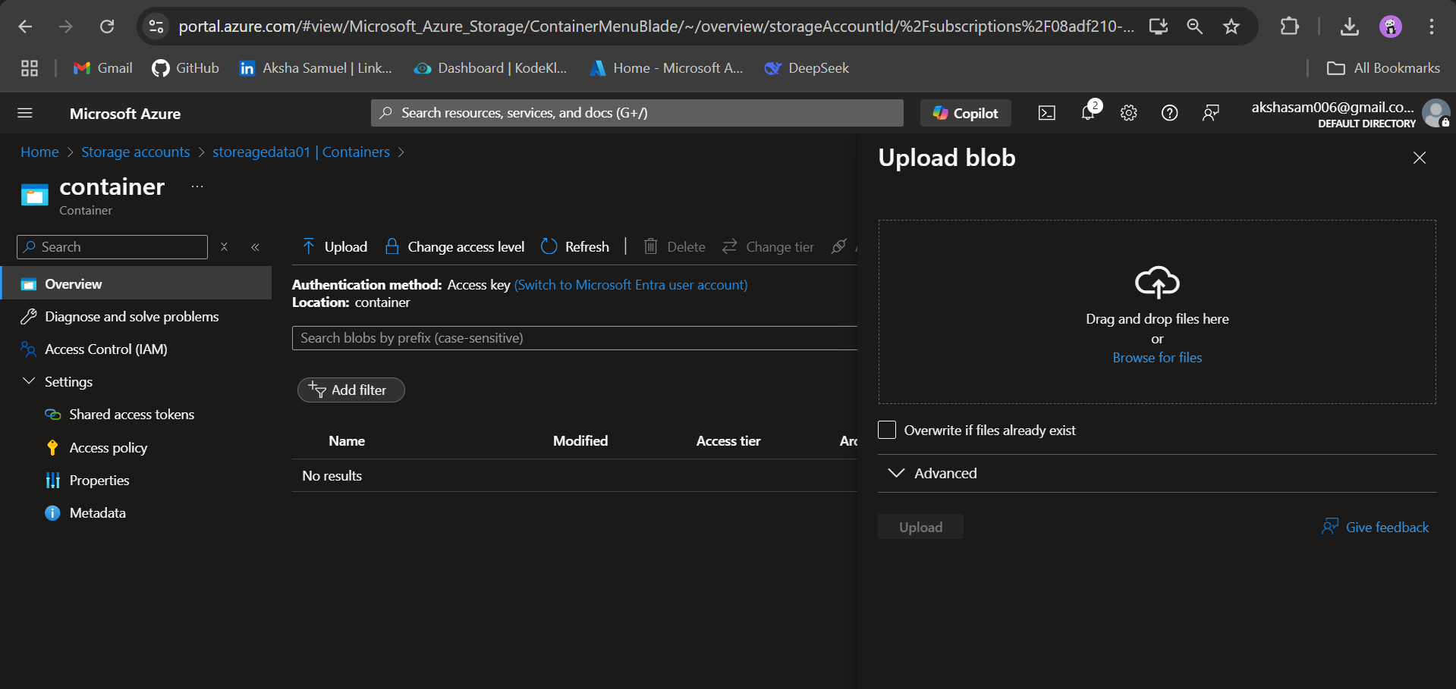

**Step 4: Download Files from the Blob Container**

1. Open the **Blob Container** and find the uploaded file.
2. Click on the file and select **"Download"**.
3. The file will be downloaded to your local system.

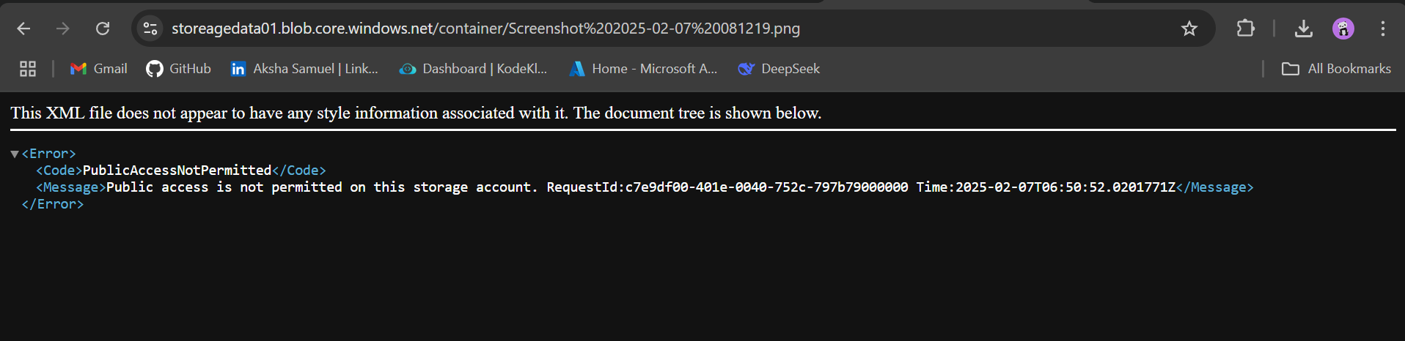

**Step 5: Configure Access Permissions**

**Role-Based Access Control (RBAC)**

1. In the **Storage Account**, go to **"Access Control (IAM)"**.
2. Click **"Add" → "Add role assignment"**.
3. Choose a role:
   * **Storage Blob Data Reader** (Read-only access).
   * **Storage Blob Data Contributor** (Read and write access).
   * **Storage Blob Data Owner** (Full control).
4. Assign it to a user, group, or service principal.
5. Click **"Review + Assign"**.



